LAB TEN PROGRAM
stock.html
<!DOCTYPE html>
<html lang="en">
<head>
<meta charset="UTF-8">
<meta name="viewport" content="width=device-width, initial-scale=1.0">
<title>LabTen</title>
<script src="server.js"></script>
</head>
<body>
<center>
<h1>REAL-TIME <br>Fetching of Simple Balance Sheet Statement</h1>
<table id='tb1' border="1">
<tr>
<th style="width: 90px;">Date</th>
<th style="width: 120px;">Receivables</th>
<th style="width: 120px;">Cash and cash equivalents</th>
<th style="width: 120px;">Total currency assets</th>
<th style="width: 120px;">Payables</th>
<th style="width: 120px;">Net Debt</th>
</tr>
</table>
</center>
<script>
window.addEventListener('DOMContentLoaded', async () => {
const fetchData = async (url) => {
try {
const response = await fetch(url);
if (!response.ok) {
throw new Error(`HTTP error! Status: ${response.status}`);
}
return await response.json();
} catch (error) {
console.error(`Error fetching data from ${url}:`, error);
return null;
}
};
const processAndDisplayData = (data) => {
const table = document.getElementById("tb1");
const tr = document.createElement('tr');
for (const key of ["date", "netReceivables", "cashAndCashEquivalents", "totalCurrentAssets", "accountPayables", "netDebt"]) {
const td = document.createElement('td');
td.innerHTML = data[key];
tr.appendChild(td);
}
table.appendChild(tr);
};
const companiesUrl = 'companies.json';
comp=await fetchData(companiesUrl);
for (let i = 0; i < comp.length; i++) {
const apiKey = 'GET_YOUR_OWN_API_https://financialmodelingprep.com/developer';
apiUrl = `https://financialmodelingprep.com/api/v3/balance-sheet-statement/${comp[i]}?period=annual&apikey=${apiKey}`;
data = await fetchData(apiUrl);
if (data) {
processAndDisplayData(data[0]);
}
}
});
</script>
</body>
</html>

companies.json
["AAPL","PRAA","GOOGL"]

server.js
if ("serviceWorker" in navigator) {
navigator.serviceWorker
.register('sw.js')
.then((reg)=>console.log('registered',reg))
.catch((err)=>console.log('err',err));
} else {
console.log("No service worker support in this browser");
}

sw.js
self.addEventListener('install', event => {
console.log('Service worker installing');
self.skipWaiting();
});

self.addEventListener('activate', event => {
console.log('Service worker activating...');
});

self.addEventListener('fetch', event => {
console.log('Fetching', event.request.url);
});

OUTPUTS:

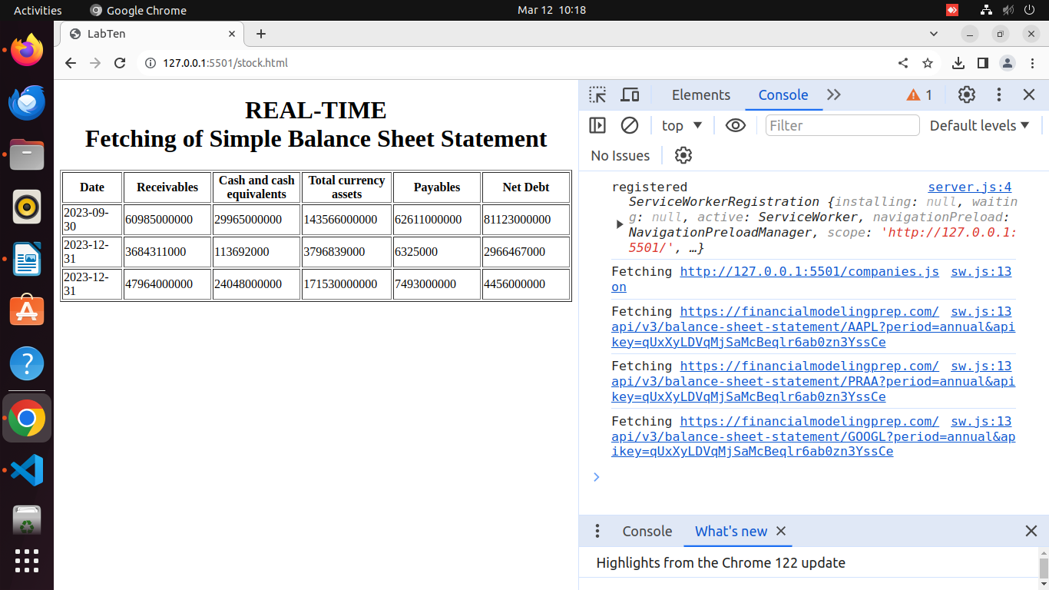
Figure : Using sw.js and start.js(server.js)

